Systems Reliability & Software Quality Engineering
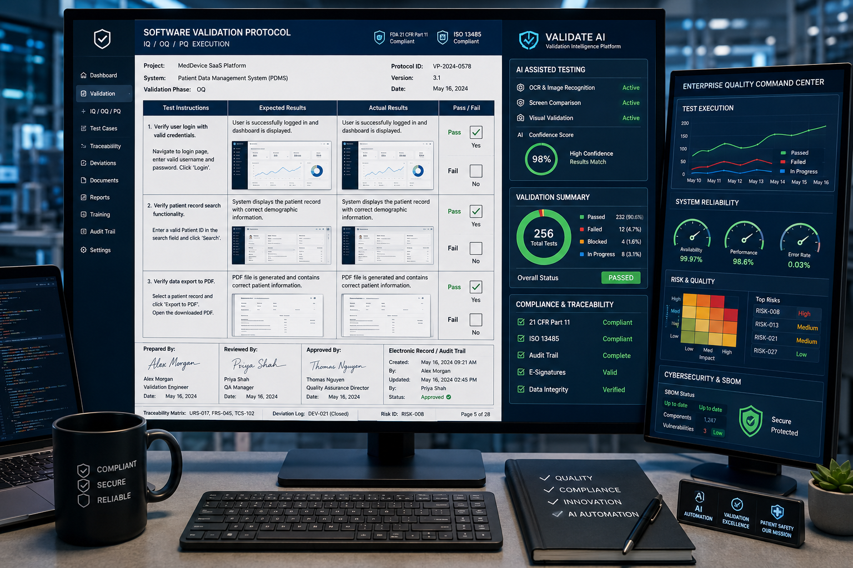
My role: Software Quality & Systems Engineering Lead
Project description:
Led software quality engineering and system reliability initiatives for complex enterprise and networking systems. Defined and executed verification and validation strategies, automated testing frameworks, and KPI-driven quality improvements across multidisciplinary engineering teams. Collaborated with software, hardware, and QA organizations to improve system performance, reduce testing cycles, strengthen release quality, and support scalable software delivery in high-availability environments
Skills and deliverables
- Software QA
- Systems Engineering
- Test Automation
- Agile Project Management
- Product Management

